ROAR T-shirt

T-Shirt Size Form

**Your child’s student activity fee covers this cost (K-5)!**

Order forms are due on **Friday, August 25**

Please fill out one form per TKA K-5 student and return it to your homeroom teacher by Friday, August 25th.

Your child’s shirt will be in the color chosen by their homeroom teacher to serve as their field trip shirt.

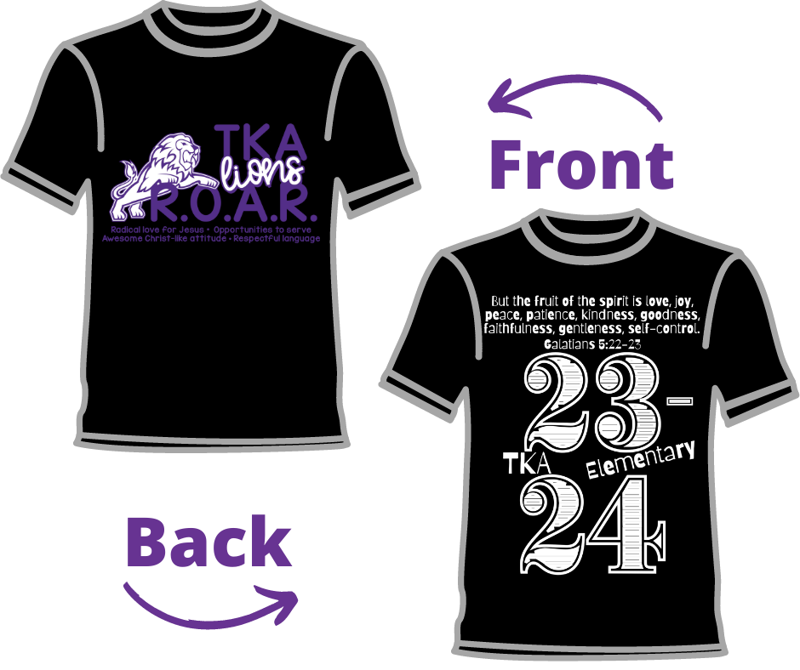

** Your child’s shirt will be in the color chosen by their homeroom teacher.

Student Name: ________________________________________ Grade: ___________

Teacher (Homeroom): ____________________________________

_______ YXS _________ Small _______ 2-XL

_______ YS _________ Medium ______ 3- XL

_______ YM _________ Large

_______ YL _________ XL

*No money needed. Please fill out and return the form to your homeroom teacher by Friday, August 25.