ROAR T-shirt Pre-Order form

for friends and family of tka Elementary

**$15 per shirt**

Order forms and money are due on **Friday, August 25**

Any family member or friend of TKA Elementary wanting to purchase a ROAR shirt, the cost is $15 per shirt. All friends/family of TKA Elementary shirts will be black with purple/white print.

Order forms and money are due by Friday, August 25.

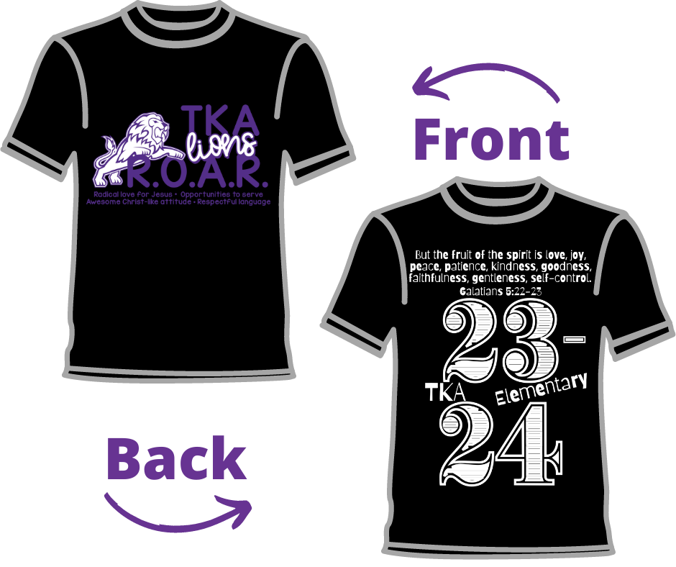

Student Name: ________________________________________ Grade: ___________

Teacher (Homeroom): ____________________________________

_______ YXS _________ Small _______ 2-XL +$3

_______ YS _________ Medium ______ 3- XL +$3

_______ YM _________ Large

_______ YL _________ XL

Total Cost ($15 per-shirt**): _______________

**Remember to add $3 per 2XL and 3XL shirt

Payment: _______ cash or ___________ check (made payable to TKA) ______ Check number

Please fill out and return the form and money to your homeroom teacher by Friday, August 25.